Create SSIS package for executing multiple dataflow task and Execute task.

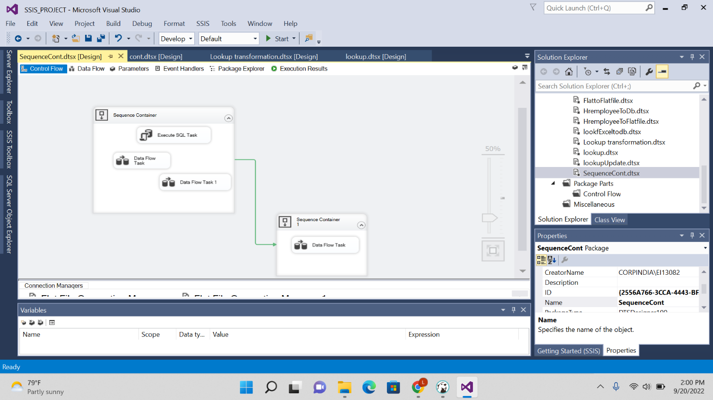

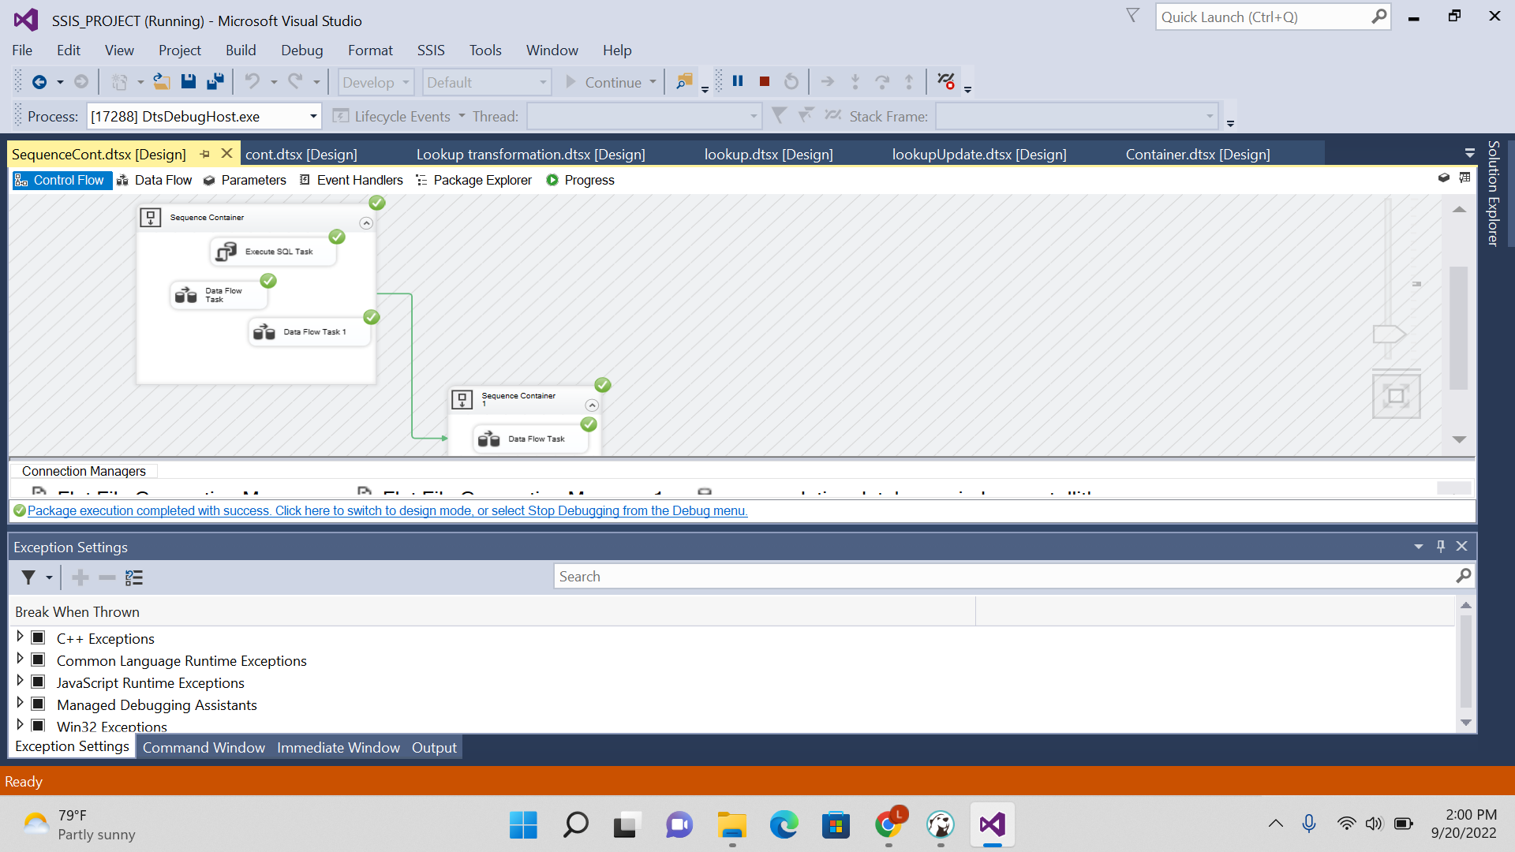

Result:

Execution task result:

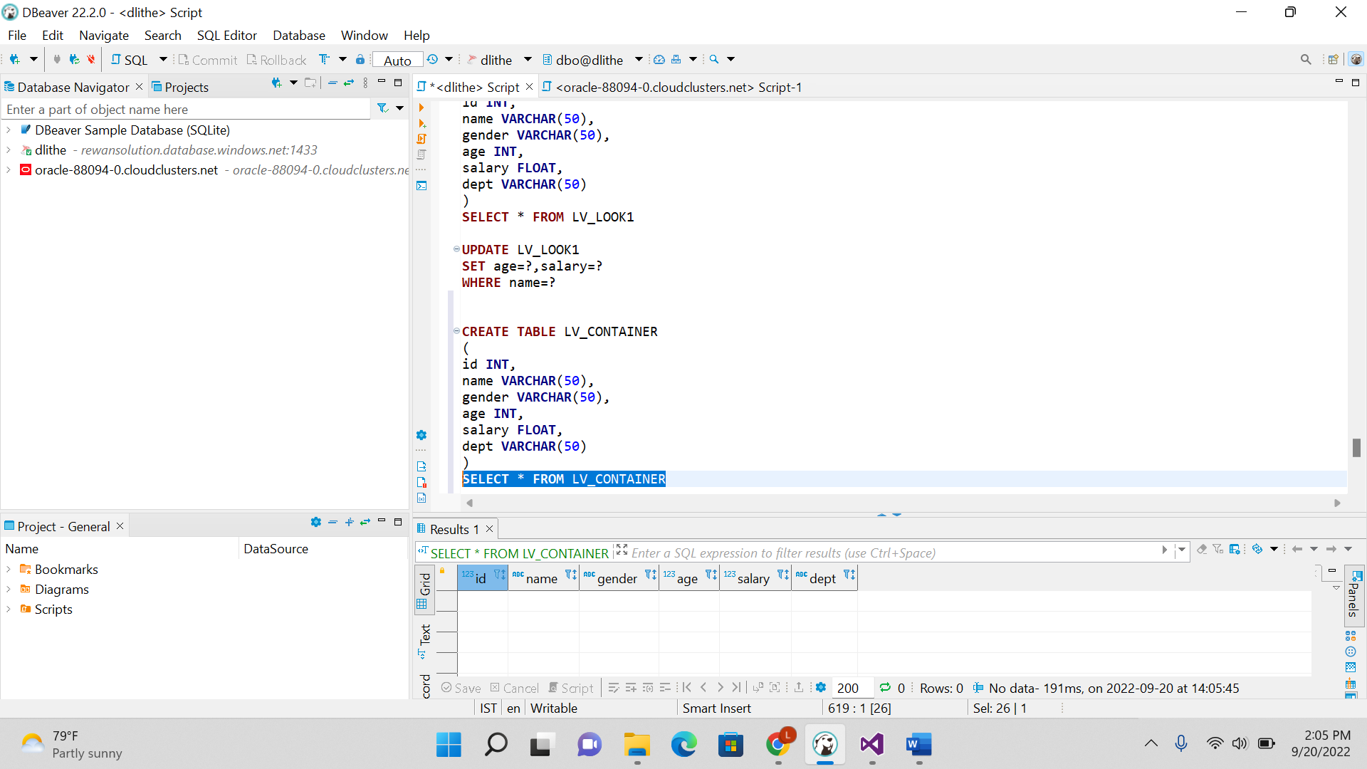

Flat dest file:

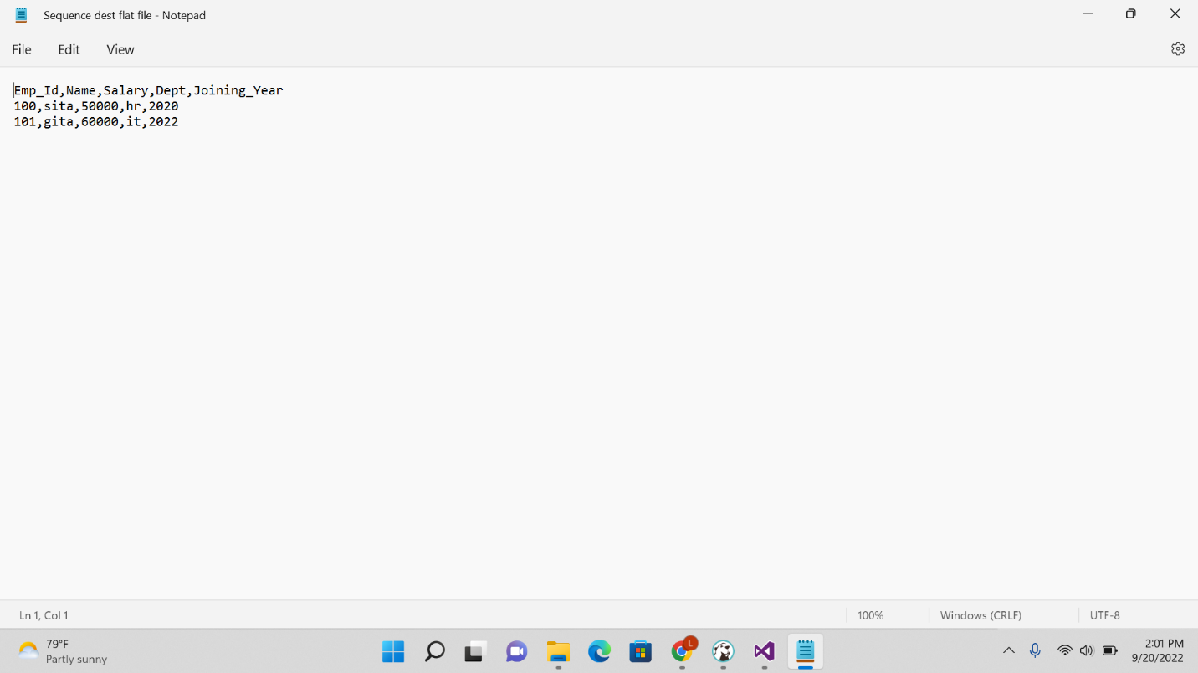

Ole db to db dest result:

Flat to ole db dest result:

